NAME : Muthivhi Unarine
STUDENT NUMBER : ST10455111
SECOND DOCUMENT: DESIGN OF A PERSONAL BUDGETING APPLICATION

1. Introduction
The purpose of this document is to design a new personal budgeting application based on the analysis of existing applications such as Mint, YNAB, and PocketGuard. These applications were evaluated in terms of their features, usability, strengths, and weaknesses in order to identify areas for improvement.
Personal budgeting applications play an important role in helping individuals manage their finances, particularly in a modern environment where financial responsibilities are increasing. Many users struggle with tracking their expenses and maintaining financial discipline, which highlights the need for an effective and user-friendly solution.
The proposed application aims to help users manage their finances effectively by combining ease of use, automation, and engaging features. This design focuses on improving user experience while addressing the weaknesses identified in existing applications, such as complexity, lack of customisation, and limited engagement (Metro Money, 2023).

2. Proposed Application Overview
App Name: SmartSpend/fintrack
Purpose:
To help users:
- Track expenses
- Create budgets
- Monitor spending habits
- Improve financial discipline
Target Users:
- Students
- Young adults
- Beginners in budgeting

3. Key Features
The application will include several key features designed to enhance usability and improve financial management:
- Expense Tracking:
This feature allows users to record and monitor their daily spending. Users can enter details such as amount, category, and date, ensuring accurate financial records are maintained.
- Automatic Categorisation:
The system will automatically assign categories to transactions where possible, reducing the need for manual input and improving efficiency.
- Budget Limits per Category:
Users will be able to set spending limits for different categories such as food, transport, and entertainment. This helps users control their spending and avoid exceeding their budgets.
- Visual Reports (Graphs and Charts):
The application will provide visual representations of spending behaviour, allowing users to analyse trends and make informed decisions.
- Notifications for Overspending:
The system will alert users when they are approaching or exceeding their budget limits, helping them adjust their spending habits.
- Gamification (Badges and Rewards):
Users will earn rewards for achieving financial goals, such as staying within budget or saving money. This increases engagement and motivation.
- “Safe to Spend” Feature:
Inspired by PocketGuard, this feature shows users how much money they have available after accounting for expenses and savings goals.
These features are designed to combine the strengths of existing applications while addressing their limitations (PocketGuard, 2026).

4. System Inputs and Outputs
Inputs (what user enters):
- Income amount
- Expenses (amount, category, date)
- Budget limits
- Savings goals
These inputs allow the system to generate accurate financial information and personalised insights.
Outputs (what system shows):
- Total balance
- Spending summaries
- Budget progress
- Alerts (overspending warnings)
- Reports (charts/graphs)
The outputs provide users with clear and meaningful information about their financial status, enabling better decision-making.

5. Application Screens (User Interface Design)
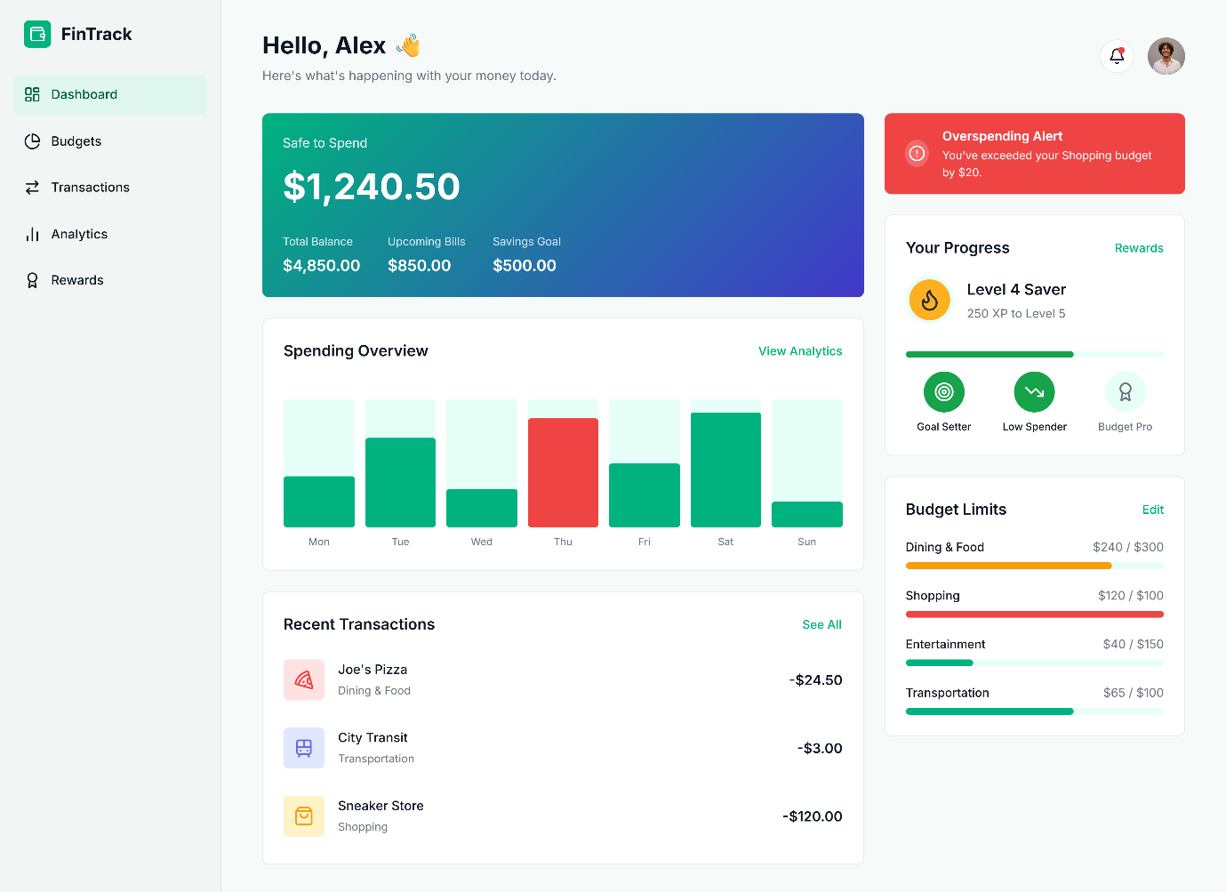

Screen 1: Dashboard
Description:
The dashboard provides an overview of the user’s financial situation. It displays total balance, recent transactions, spending summaries, and the “Safe to Spend” amount.
- Total balance
- Recent transactions
- Spending summary (chart)
- “Safe to Spend” amount
Purpose:
This screen allows users to quickly understand their financial position without navigating through multiple sections. The use of visual elements improves clarity and enhances user experience.

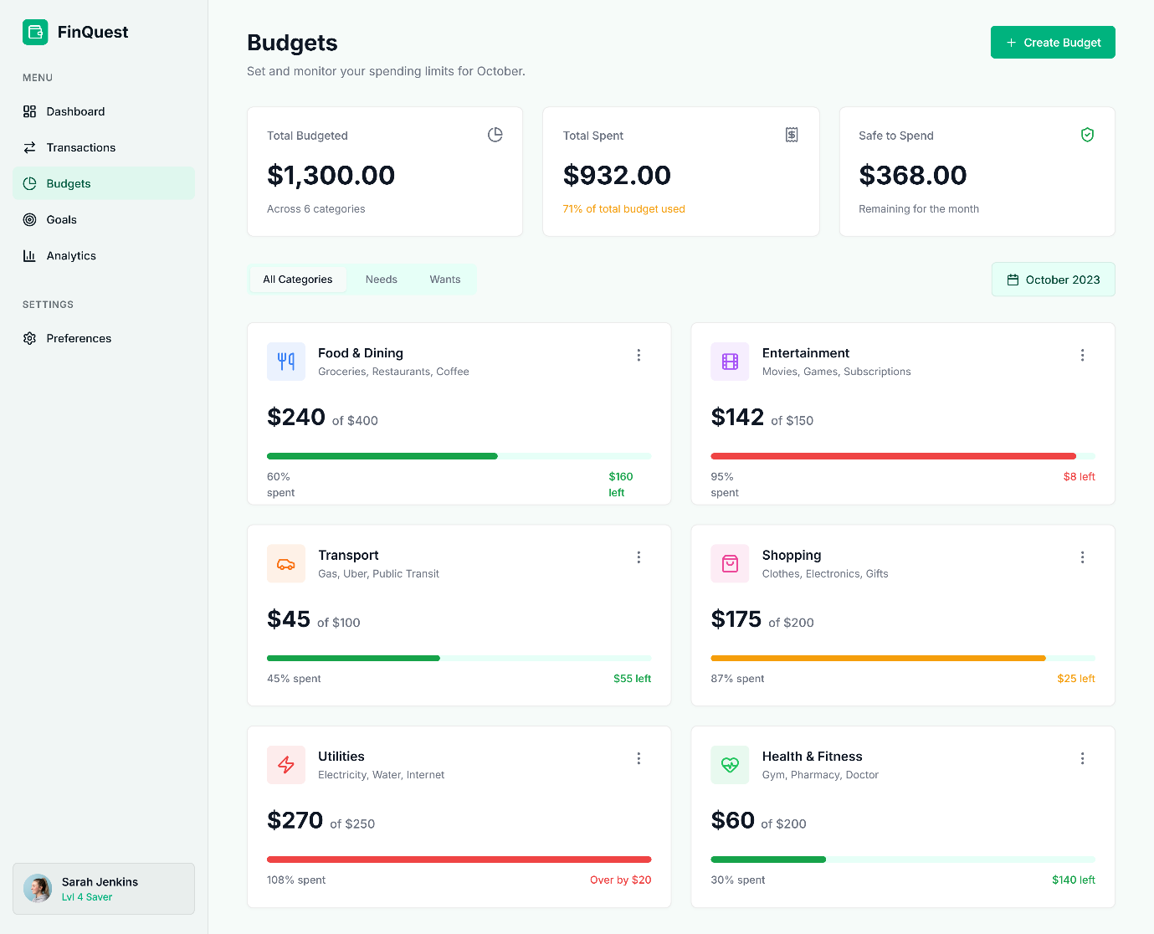
Screen 2: Budget Screen
Description:
This screen allows users to set and manage budgets for different categories such as food, transport, and entertainment. It includes:
- Progress bars
- Colour indicators (within budget / overspending)
Purpose:
To help users control spending and stay within limits.

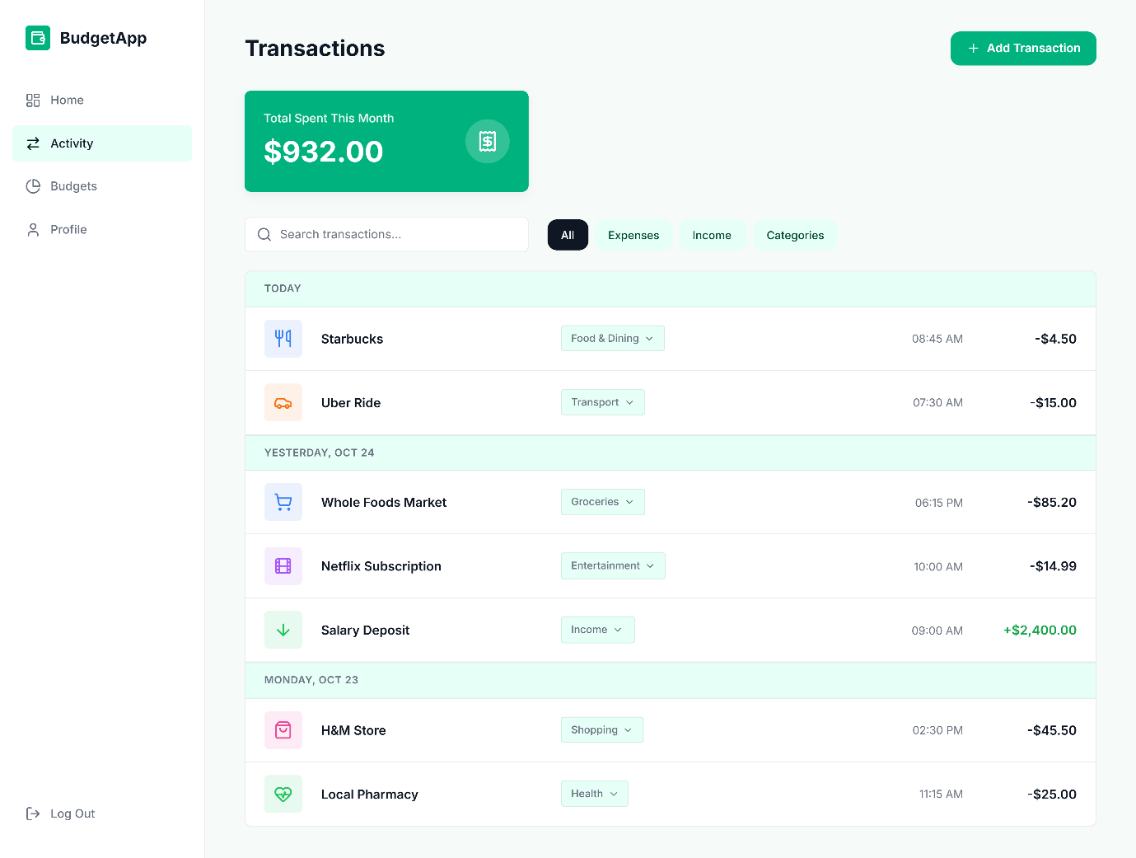
Screen 3: Expense Tracking Screen
Description:
Displays a list of all transactions including:
- Amount
- Category
- Date
Users can:
- Add new expenses
- Edit categories
Purpose:
To track daily spending accurately.
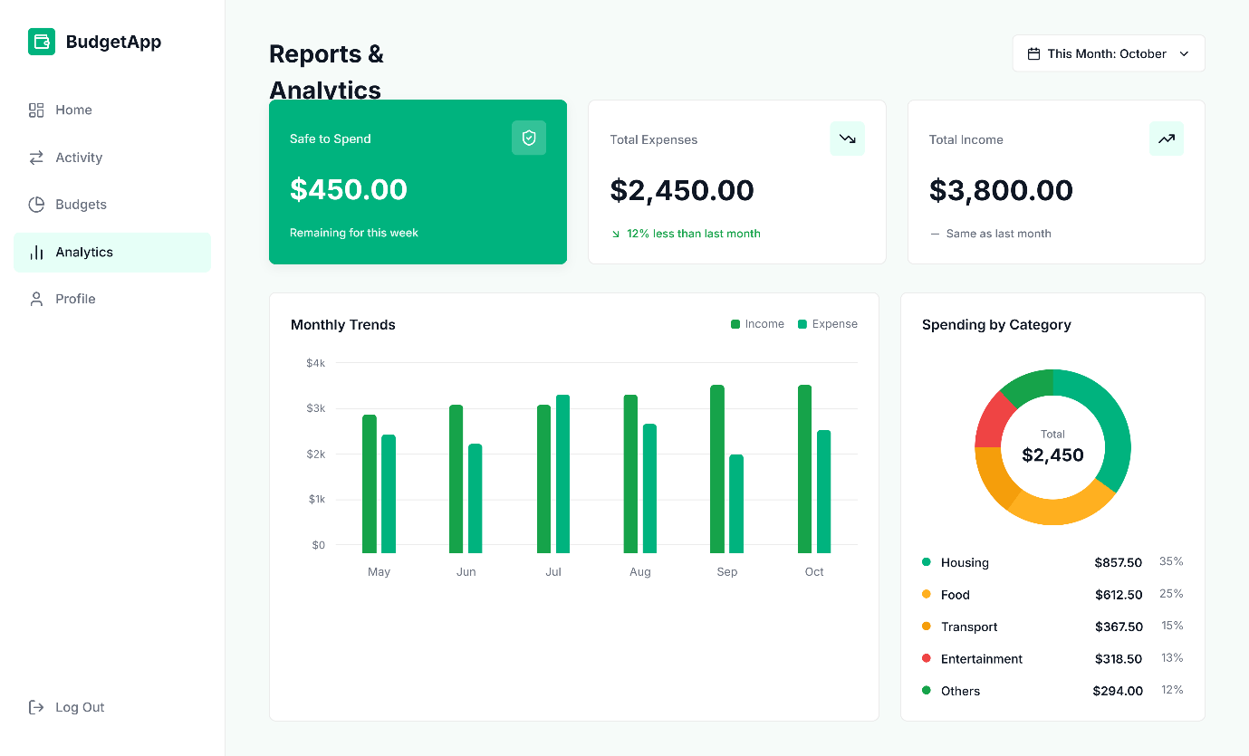

📱 Screen 4: Reports / Analytics
Description:
Shows graphs and charts such as:
- Spending by category
- Monthly trends
Purpose:
To help users analyse their financial behaviour.
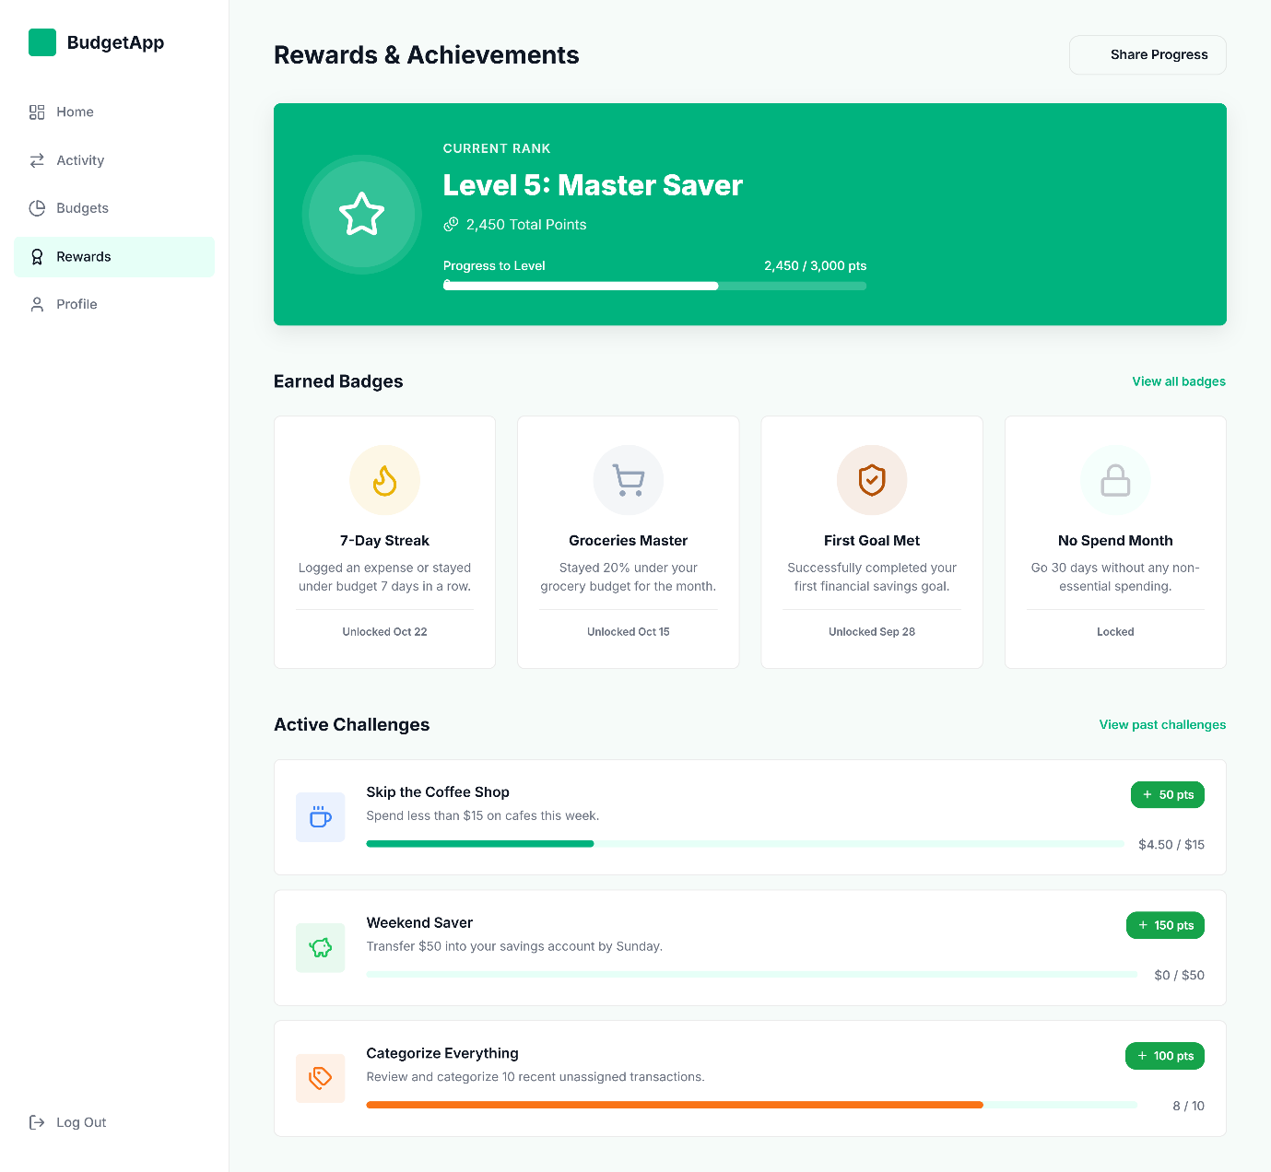

Screen 5: Rewards / Gamification
Description:
Users earn badges or points for:
- Staying within budget
- Saving money
Purpose:
To motivate users and make budgeting engaging.

6. Navigation Flow
The application will use a simple and intuitive navigation structure consisting of the following sections:
- Dashboard
- Budget
- Transactions
- Reports
- Profile
Users will navigate using a bottom navigation bar, which provides quick access to key features. This design improves usability by reducing the number of steps required to access different sections of the application. A simple navigation system is particularly important for beginner users, as it ensures a smooth and user-friendly experience.

7. Basic Algorithm (How the App Works)
- User enters income
- User sets budget categories
- User adds expenses
- System categorises expenses automatically
- System updates budget progress
- If spending exceeds budget → notification is sent
- Reports and graphs are updated in real time
This process ensures that users receive continuous feedback on their financial activity, improving awareness and decision-making.

8. Data Storage (Basic Database Design)
The application will store data in the following tables:
User Table
- UserID
- Name
- Email
- Password
Transaction Table
- TransactionID
- Amount
- Category
- Date
- UserID
Budget Table
- Category
- Limit
- UserID
This structure ensures efficient storage and retrieval of data, allowing the application to function smoothly and securely.

9. Evaluation of Design
Strengths:
- Easy to use and beginner-friendly
- Combines best features from existing apps
- Engaging through gamification
- Provides clear financial insights
These strengths make the application highly effective in improving financial awareness and encouraging consistent use.
.
Possible Limitations:
- Requires user input for accuracy
- Notifications may become overwhelming
These limitations highlight areas for future improvement, such as increasing automation and allowing users to customise notification settings.

10. Conclusion
The proposed application improves on existing budgeting applications by combining simplicity, automation, and user engagement. By analysing applications such as Mint, YNAB, and PocketGuard, valuable insights were gained into what makes a budgeting application effective.
The design focuses on addressing the weaknesses identified in existing applications while maintaining their strengths. The inclusion of features such as gamification, visual analytics, and automated tracking ensures that the application is both functional and engaging.
Overall, the application aims to help users develop better financial habits while providing an enjoyable and user-friendly experience (Alibaba Life Tips, 2026).
11. References
Metro Money. 2023. The Mint app shutdown: What it means. Available at: https://www.metro-money.com (Accessed: 24 March 2026).
PocketGuard. 2026. Budgeting features and tools. Available at: https://pocketguard.com (Accessed: 24 March 2026).
FinancialAha. 2026. Budgeting app comparisons. Available at: https://www.financialaha.com (Accessed: 24 March 2026).
Alibaba Life Tips. 2026. Best personal finance tools. Available at: https://lifetips.alibaba.com (Accessed: 24 March 2026).

